

**American International University-Bangladesh (AIUB)**

**Department of Computer Science**

**Faculty of Science & Technology (FST)**

**Fall 2021-2022**

**Software Quality and Testing**

**Sec: A**

**Title: Assignment on Selenium**

Assignment Submitted By:

|  |  |
| --- | --- |
| **Name** | **ID** |
| FARJUM HAIDER | 18-38360-2 |
| ABU BAKAR SIDDIQUE | 18-38381-2 |
| UMMA KHADIZA | 18-38311-2 |

**Question 1 : Put all screenshots of your computer during installing Selenium.**

**Got to this link :** <https://www.selenium.dev/>

**Go to download section**



**Next : Python Download**



**Next : Install Vscode**

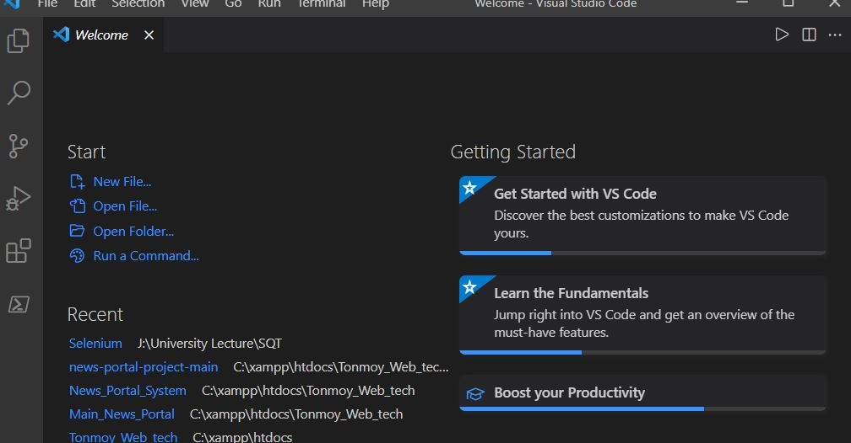

**Next : Python Extension Download in Vscode**

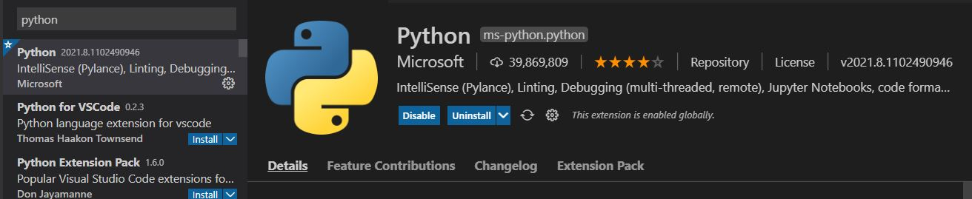

**Next : Code Runner install**

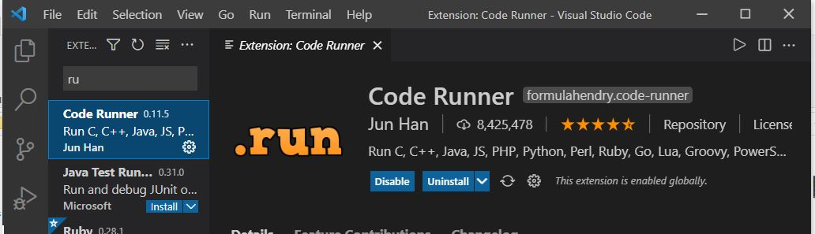

**Next :** **Download ChromeDriver .**

***Select Download link***

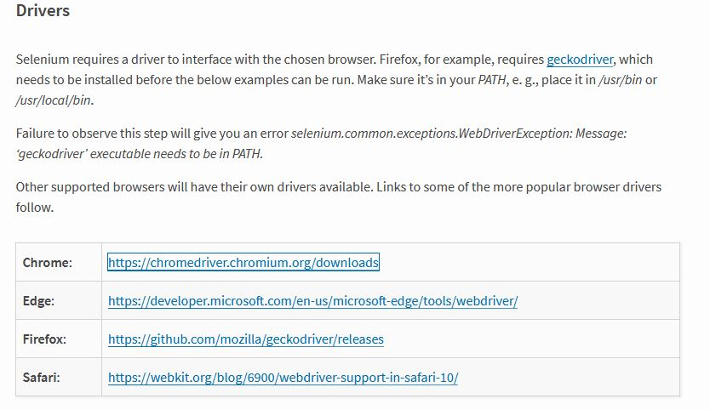

**Next : select version with match desktop chrome application version**

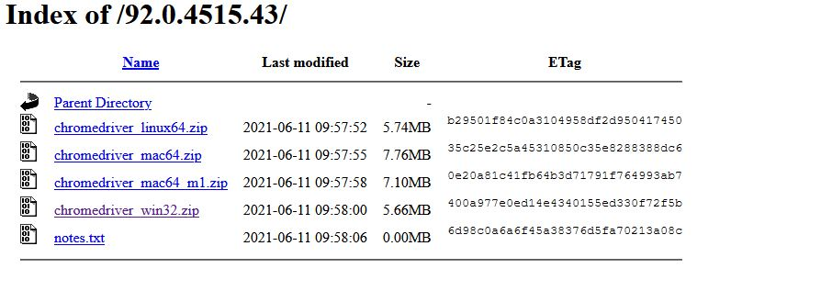

**Next : Install Virtual Environment**

**Pip install pipenv**

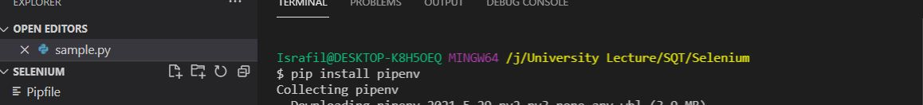

**Next : Install Selenium**

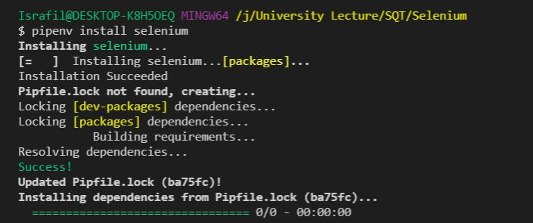

**Question 2: Describe the benefit of automated testing and specialty of Selenium.**

To ensure quality, software tests must be performed often during development cycles. Software package tests should be repeated whenever source code is modified. Each software unharness should be tested on all supported operating systems and hardware configurations. The cost of manually repeating these tests is high and time-consuming. Automatic tests can be done over and over again at no additional expense, and they are far faster than manual testing. The time it takes to execute repetitious tests will be reduced from days to hours thanks to automated software testing. A time savings that translates into a cost saving.

The most widely used software and open supply automation tool is Selenium. The benefits of selenium in terms of automation are enormous. It also has the ability to record and playback for testing web apps, as well as run multiple scripts across several browsers. The benefits of selenium look at Automation are applicable to a wide range of industries.

* **Open-Source:** As previously stated, Selenium's most important strength is that it is both a software system and a portable tool. There are no direct costs involved. The tool, as well as community-based support for it, is available for free download.
* **Language support:** Selenium supports a wide range of languages, including Java, Perl, Python, C#, Ruby, Groovy, JavaScript, and others. It has its own script, but it is not limited by that language. It will work with a variety of languages, regardless of the developers' or testers' familiarity with them.
* **Supports Multiple Operating Systems:** Selenium can run and support a variety of operating systems, including Windows, Mac OS X, Linux, and UNIX. With the Selenium suite of tools, a customized look acting suite can be created on any platform and then killed on another. Create test cases for Windows OS, for example, and run them on a Linux–based machine with simplicity.
* **Browser support:** Selenium provides support for several browsers, including Internet Explorer, Chrome, Firefox, Opera, and Safari. When it comes to running tests and testing them across multiple browsers at the same time, this becomes rather clever.
* **Compatibility with programming languages and frameworks:** Selenium works with a variety of programming languages and frameworks. It can, for example, integrate with the Emmet or Champion frameworks for source code compilation. It can also be used in conjunction with the Testing framework to test applications and generate reports. For Continuous Integration (CI), it can integrate with Jenkins or Hudson, and it may also integrate with other open-source tools to offer other functionalities.
* **Tests on several platforms:** Selenium Test Automation may be used to automate mobile web applications on Android, iPhone, and Blackberry. This can aid in the generation of necessary results and the ongoing resolution of challenges.
* **Continuous updates:** Selenium support is community–based, and updates and upgrades are made on a regular basis. These enhancements are easy to achieve and do not necessitate any special training. As a result, element is both capable and efficient.
* **Loaded Selenium suites:** Selenium is more than just a single tool or utility; it's a loaded package of numerous testing tools, which is why it's called a Suite. Each tool is tailored to specific testing requirements and test environments. Selenium also supports Selenium IDE, Selenium Grid, and Selenium Remote Control (RC).
* **Ease of use:** Selenium provides a user-friendly interface that makes it simple to create and run tests. Its open-source features enable users to script their own extensions, making them simple to construct, custom-built activities, and even manipulating at a high level. Users can observe the tests as they run in their browsers. Furthermore, one of the reasons for choosing selenium is that it allows testers to extract results and execute follow-up activities because to its news capabilities.
* **Re usability and Add-ons:** The Selenium Test Automation framework makes use of scripts that can be run in many browsers at the same time. Selenium allows you to run several tests at the same time because it covers practically all areas of functional testing through the use of add-on tools.

Another way of thinking discusses several flaws in chemical element automation testing. Chemical element, for example, isn't a widely used tool for automating the testing of web applications, according to Test Automation experts, because it requires third-party frameworks and language support to be fully functional and produce the desired results.

**Question 3: Practice a dummy project testing in Selenium and put all screenshots from your computer during practicing it.**

**Dummy Project : GoogleSearchTest.py**

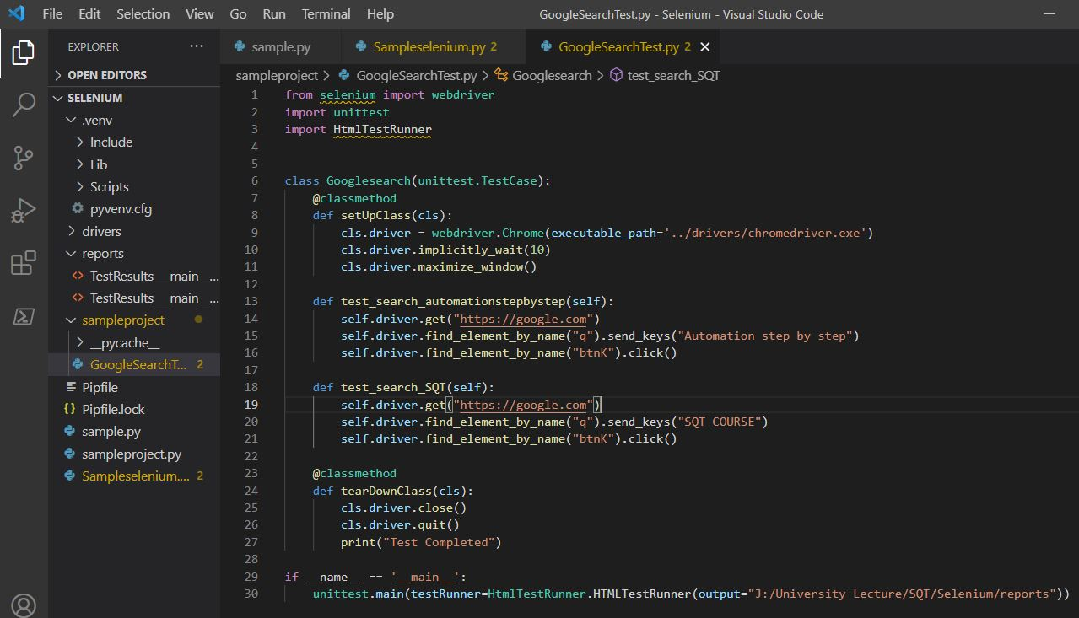

**Running Test :**

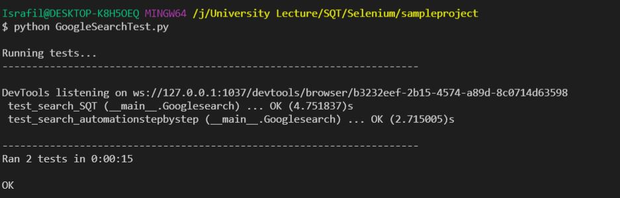

**Question 4: Show all the test results of your practice in the report.**

**Result – 1 :**

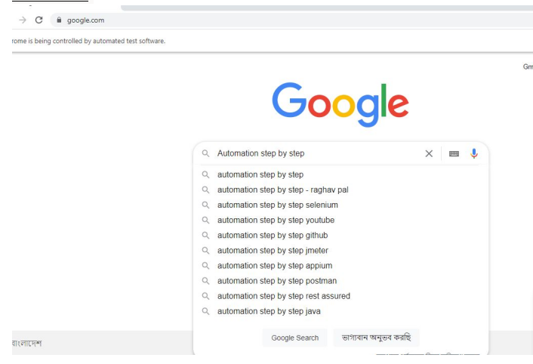

**Result-2**

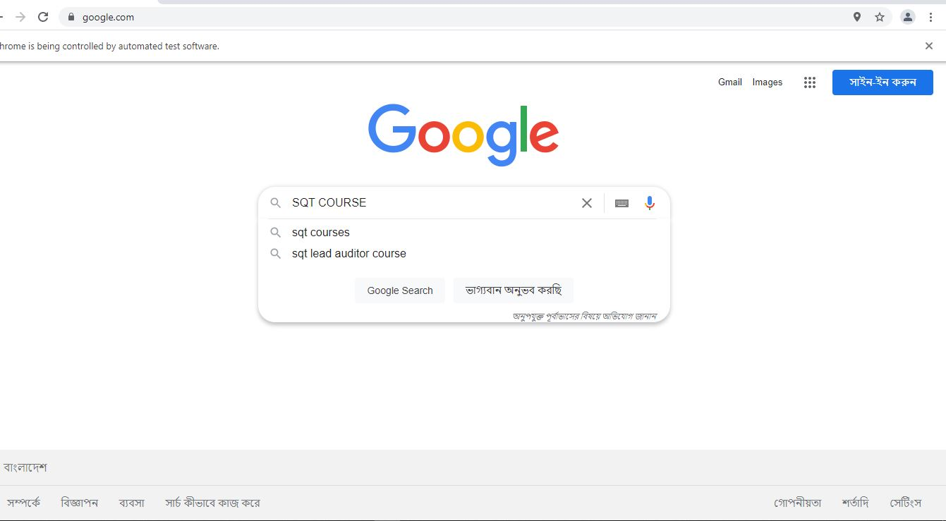

**Result – 3 :**

**Final Report – 1st Attempt to Failed :**

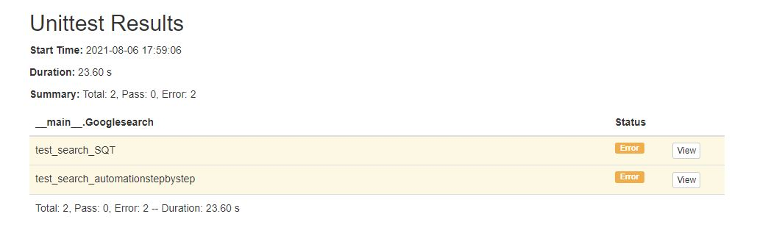

**Result – 4:**

**Final Report – 2nd Attempt to Pass :**

